**PROPOSED TITLE: -**

Krishak

**Field of invention**: -

The invention pertains to the field of agriculture and technology, particularly in creating a digital platform to facilitate the sharing and rental of farm equipment.

**Background:**

Small and medium-sized farmers often face challenges in accessing and affording agricultural machinery, which hinders their productivity and sustainability. Traditional methods of equipment ownership can be financially burdensome for these farmers. Hence, there is a need for an affordable solution that enables farmers to access necessary farm equipment conveniently.

**Objectives:**

1. To develop a web-based platform connecting farmers with farm equipment owners for sharing or rental purposes.
2. To reduce the financial burden on small and medium-sized farmers by providing cost-effective access to farm equipment.
3. To optimize equipment utilization through intelligent scheduling and resource allocation algorithms, minimizing downtime and increasing efficiency.

**Flow chart/Model:**

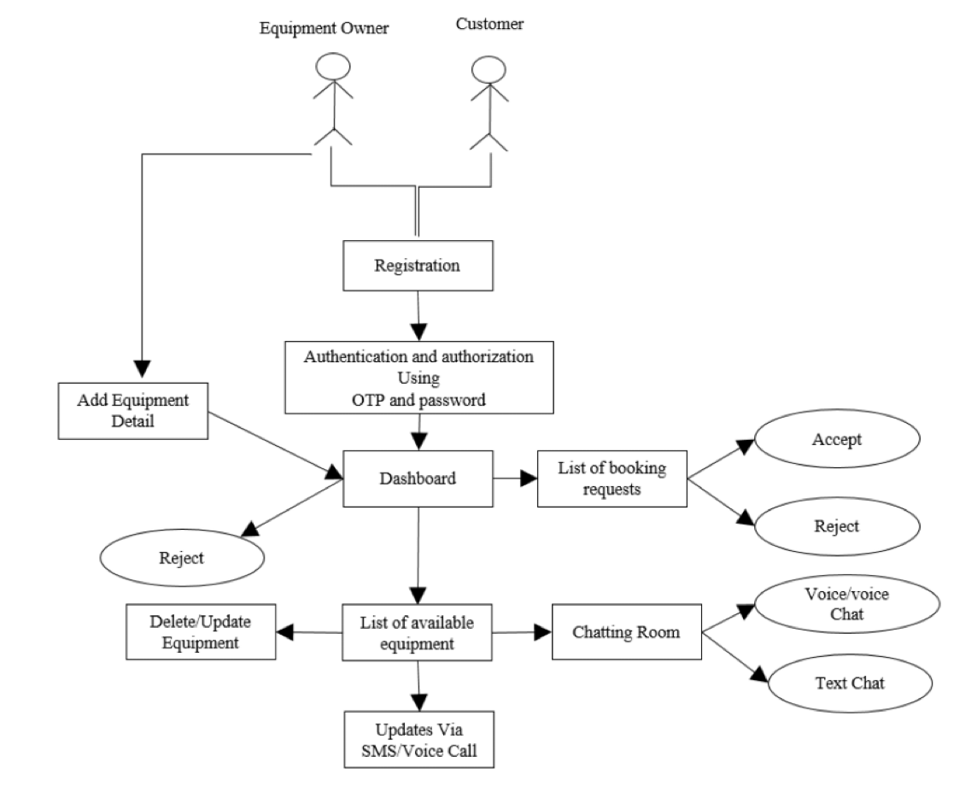

**Claims:**

1. A web-based platform for facilitating farm equipment sharing and rental.
2. An intelligent scheduling algorithm for optimizing equipment utilization.
3. A payment processing system integrated into the platform for secure transactions.
4. A user-friendly interface for seamless interaction between farmers and equipment owners.

**Technology used:**

Software:

* HTML
* CSS
* JavaScript
* React JS
* Python
* Payment Processing APIs
* Web Framework (Django Rest Framework)
* MySQL

Hardware:

* Laptop

**Proposed Methodology**

Methodology includes the introduction of different modules that we are going to incorporate in our website:

**User Registration Module**

* Users can register on the platform by providing their email address and creating a password.

**Authentication and Authorization Module**

* Once a user registers, they will need to authenticate themselves by entering their email address and password to log in to the platform.
* The platform will need to have an authorization system in place to ensure that only registered users can access the platform's features.

**Equipment Owner Module**

* This module allows equipment owners to add their equipment to the platform.
* Owners can add details about their equipment, such as the type of equipment, its condition, location, and availability.
* Owners can also set their own rental rates for their equipment.

**Customer Module**

* This module allows customers to search for equipment that they need to rent.
* Customers can filter their search results by location, type of equipment, and availability.
* Customers can also view details about the equipment, including photos, descriptions, and rental rates.

**Booking Module**

* Once a customer finds a piece of equipment that they want to rent, they can submit a booking request through the platform.
* The equipment owner will then be notified of the booking request and can either accept or reject it.
* If the owner accepts the request, the customer will be able to pay for the rental through the platform.

**Communication Module**

* The platform should have a communication module that allows customers and equipment owners to communicate with each other.
* This could include a chat feature, a messaging system, or an email system.

**Payment Processing Module**

* The platform should have a secure payment processing module that allows customers to pay for rentals online.
* The platform should also have a system in place to collect and disburse payments to equipment owners.

**Review and Rating Module**

* The platform should allow customers to review and rate their rental experiences.
* This will help to ensure that the platform is a safe and reliable place for both customers and equipment owners.

**Advantage:**

* Affordable access to farm equipment for small and medium-sized farmers.
* Increased efficiency and productivity in agriculture.
* Reduction in financial burden through cost-effective sharing and rental options.
* Convenient and user-friendly platform for seamless interaction.

**Conclusion:**

Krishak offers a transformative solution to address the pressing need for affordable access to farm equipment among small and medium-sized farmers. By leveraging technology and intelligent algorithms, Krishak aims to foster increased productivity and sustainability in agriculture while minimizing financial barriers for farmers.